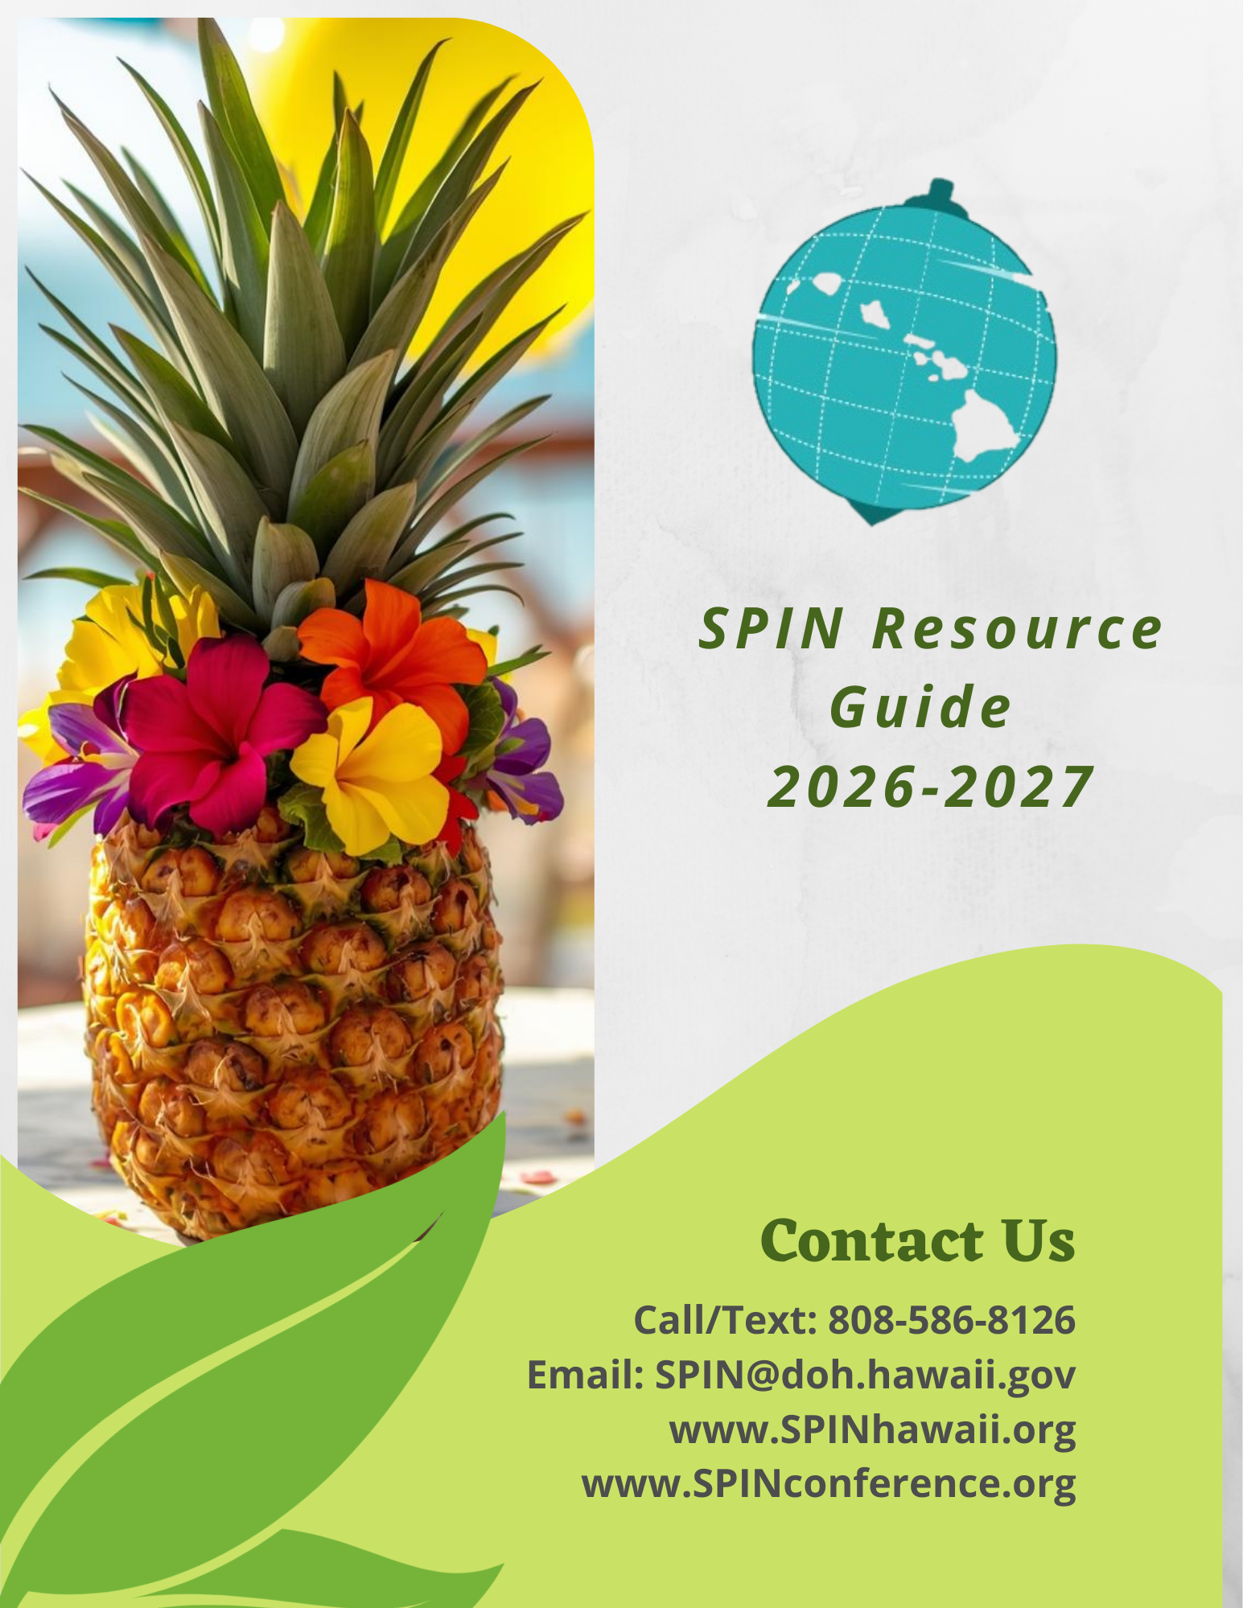

SPIN updates this print version of the Resource Guide annually, before each SPIN Conference. We update the digital version of the Resource Guide all year long on our website www.spinhawaii.org. If you come across information in this guide that needs to be changed or updated, or if you know of a resource we have missed, please contact SPIN.

We encourage you to contact us, share your email and join our SPIN News and E-Blast lists to receive our quarterly newsletter and weekly email blasts of community events.

Phone: 808-586-8126
Email: spin@doh.hawaii.gov

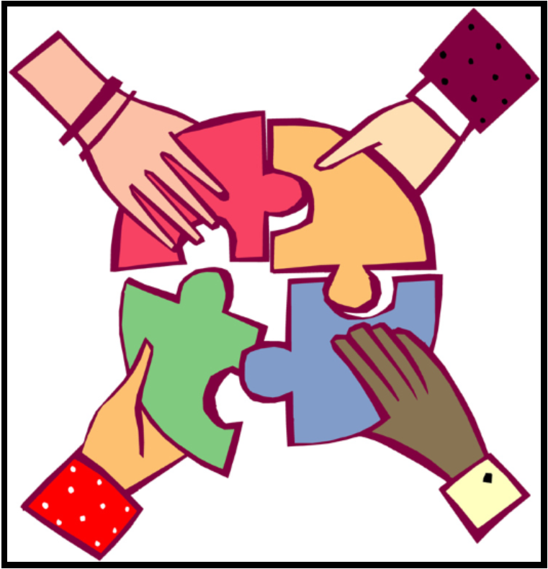

Resources in this Guide are divided into four main categories:

- Early Intervention and School Supports
- Health Supports
- Advocacy, Government and Organization Supports, and
- Ohana, Neighborhood and Community Supports


Early Intervention & School Supports

Early Intervention Services

Early Intervention Section  Department of Health  1010 Richards Street, Room 811  Honolulu, HI 96813  Phone: (808) 594-0000  Fax: (808) 586-0015  Early Intervention referral line:  Phone: (808) 594-0066  Fax: (808) 586-0016  Neighbor Islands: 1-800-235-5477  Website: https://health.hawaii.gov/eis/ | Provides assessment, planning and implementation of services statewide to support the development of infant and toddlers with special needs from birth to 3. Provides consultation, instruction and direct services to parents and caregivers to increase their knowledge and ability to support their child’s development in their natural environment.

Developmental Screening

(LDAH) School Readiness Project  Honolulu Office:  245 N. Kukui Street, Suite 205  Honolulu, HI 96817  Phone: (808) 536-9684  Ma‘ili Office:  87-790 Kulauku St. Suite A 116  Waianae, HI 96792  Phone: (808) 696-5361  Website: https://www.ldahawaii.org/school-readiness-project/ | Provides developmental, social emotional, autism, hearing and vision screening for children ages two through five years old throughout Oahu and Hilo. In addition, case management and parent training on developmental milestones and the importance of early detection in children to be ready for school, ready to learn, is provided.

It is vital that when educating our children’s brains that we do not neglect to educate their hearts.
~Dalai Lama

Department of Education - State Level Support Offices

Exceptional Support Branch  Helen Kaniho, Director  475 22nd Avenue  Honolulu, HI 96816  Phone: (808) 305-9750  Email: helen.kaniho@k12.hi.us  Website: https://hawaiipublicschools.org/school-services/parent-rights/special-education-directory/ | Provides technical assistance and training to complex areas, districts, schools, cooperating agencies and parents to address the needs of children with disabilities. Develops procedures and standards of practice for the education of students with disabilities, ages 3 to 22. Develops and manages statewide contracts, agreements and affiliations to ensure students receive services by qualified staff.
Special Education Section  Verna Chinen, Administrator  475 22nd Avenue  Honolulu, HI 96816  Phone: (808) 305-9750  Email: verna.chinen@notes.k12.hi.us | Ensures the rights of children/youth with disabilities and their parents are protected through the implementation of federal and state laws. Provides technical assistance and training to schools and complex areas on the implementation of IDEA and Chapter 60.
Special Needs Section  Jamia Green, Administrator  Email: jamia.green@notes.k12.hi.us  475 22nd Avenue  Honolulu, HI 96816  Phone: (808) 305-9785  Email: jamia.green@k12.hi.us | Focuses on programs for low incidence disabilities like autism, deafness, visual disabilities and multiple disabilities. Responsibilities include: providing leadership, training and technical assistance to schools and complexes in planning and implementing programs for these students with disabilities; and providing direct services like assessments for students with hearing and vision disabilities, and students with significant cognitive, social and behavioral needs.

Department of Education - District/Complex Level Support Offices

Direct support and supervision to schools is provided through 15 complex area offices that take in Hawaii’s 41 school complexes. (A complex is made up of one or more high schools and the elementary and middle schools that feed students to the high school.) Each complex area has a Complex Area Superintendent (CAS) and a District Educational Specialist (DES) for special education/special services. The DES may cover more than one complex area. The following is a list of important contacts for special education supports in each district:

OAHU: Honolulu District
Farrington-Kaiser-Kalani Complex Area
Kaimuki-McKinley-Roosevelt Complex Area
3440 Leahi Ave., Bldg. D
Honolulu, HI 96815
IDEA Student Support Services
Farrington-Kaiser-Kalani (808) 784-6680
Kaimuki-McKinley-Roosevelt (808) 784-6690
School Based Behavioral Health (808) 784-6820

OAHU: Central District
Aiea-Moanalua-Radford Complex Area (Central South)
1 C Ave. Bldg. H
Honolulu, HI 96818
Leilehua-Mililani-Waialua Complex Area (Central North)
1136 California Avenue
Wahiawa, HI 96786
IDEA Student Support Services
Aiea-Moanalua-Radford (808) 421-4263
Leilehua-Mililani-Waialua (808) 622-6432
School-Based Behavioral Health (808) 622-6432
Autism Program (808) 622-6432

OAHU: Leeward District
Campbell-Kapolei Complex Area
Nanakuli-Waianae Complex Area
Pearl City-Waipahu Complex Area
Leeward Annex
94-521 Farrington Highway
Waipahu, HI 96797
IDEA Student Support Services
Campbell-Kapolei (808) 509-1463
Nanakuli-Waianae (808) 784-5696
Pearl City-Waipahu (808) 675-0384
School-Based Behavioral Health
Campbell-Kapolei (808) 509-1463
Nanakuli-Waianae (808) 675-0444
Pearl City-Waipahu (808) 384-2956
Autism Program (District Wide) (808) 675-0384

OAHU: Windward District
Castle-Kahuku Complex Area
Kailua-Kalaheo Complex Area
46-169 Kamehameha Highway, Kaneohe, HI 96744
IDEA Student Support Services

Castle-Kahuku (808) 784-5940
Kailua-Kalaheo (808) 784-5940
School-Based Behavioral Health (808) 784-5930
Autism Program (808) 784-5950

Hawai‘i District: East Hawai‘i Regional Special Education Office
Hilo-Waiakea Complex Area
450 Waianuenue Avenue, Building C
Hilo, HI 96720
IDEA Student Support Services (808) 313-6599
School-Based Behavioral Health (808) 313-6602
Autism (808) 313-6599 or (808)313-6602

Hawai‘i District: South Hawai‘i Regional Special Education Office
Ka‘u-Kea‘au-Pahoa Complex Area
16-590 Kea‘au-Pahoa Road, Hale F
Kea‘au, HI 96749
IDEA Student Support Services (808) 313-4580
Autism (808) 982-4252
School-Based Behavioral Health (808) 982-4275

Hawai‘i District: West Hawai‘i Regional Special Education Office
Kealakehe-Konawaena Complex Area
81-1080 Konawaena School Road
Kealakekua, HI 96750
IDEA Student Support Services (808) 323-0015
School-Based Behavioral Health (808) 313-3739

Hawai‘i District: North Hawai‘i Regional Special Education Office
Kohala-Honoka‘a Complex Area
c/o Honoka‘a High School
45-527 Pakalana Street
Honoka‘a HI 96727
IDEA Student Support Services (808) 775-8895
School-Based Behavioral Health (808) 313-3739

Maui District
Baldwin-Kekaulike-Kulanihakoi-Maui Complex Area
P.O. Box 263
Pu‘unene, HI 96784
IDEA Student Support Services (808) 264-5880
Autism (808) 873-3520
School-Based Behavioral Health (808) 873-3520

Maui District
Hana-Lahainaluna-Lanai-Molokai Complex Area
P.O. Box 470
Kaunakakai, HI 96748
IDEA Student Support Services (808) 866-7414 or (808) 553-1723
School-Based Behavioral Health (808) 553-1723

Kaui District
Kapaa/Kauai/Waimea Complex Area
3060 Eiwa Street, Room 305
Lihue, HI 96766
IDEA Student Support Services (808) 274-3505
School-Based Behavioral Health (808) 274-3505
Autism (808) 274-3505

Department of Education Special Schools

Hawaii School for the Deaf & the Blind  3440 Leahi Avenue  Honolulu, HI 96815  Phone/Video Phone: (808) 447-1453  Fax: (808) 733-4824  Website: https://www.hsdb.k12.hi.us/ | A free public education facility that provides services to Hawaii’s deaf, blind, and deaf-blind students. HSDB provides an ASL bilingual-bicultural program that follows the tenets of a bicultural, bilingual philosophy. Both ASL and English are respected and used in instruction. Provides an academic boarding program for some students as determined by their IEP.

Federally Funded Preschools Serving Students with Disabilities

HEAD START  Oahu Main Office:  HCAP: Honolulu Community Action Program  94-810 Moloalo St. Room 200  Waipahu, HI 96797  Phone: (808) 847-2400  Email: headstart@hcapweb.org  Website: https://www.hcapweb.org/headstart/  HEAD START  Kauai Main Office  CFS: Child & Family Services  2970 Kele Street Suite 203, Lihue, HI 96766  Phone: (808) 245-5914  Website: https://www.childandfamilyservice.org/programs/headstart/  Maui Main Office:  MEO Family Center, Early Childhood Centers  99 Mahalani Street, Wailuku, HI 96793  Phone: (808) 249-2990  Website: https://www.meoinc.org/programs-services/early-childhood-services/meo-head-start/  Hawaii Main Office:  PACT: Parents and Children Together  27 Waianuenue Ave., Hilo, HI 96720  Phone: (808) 961-0570  Website: https://www.pacthawaii.org/head-start | Provides federally funded comprehensive early education programs for low-income children between the ages of 3-5, including children with disabilities.

Private Preschools & Programs Serving Students with Disabilities

Keiki O Ka ‘Aina Preschool Centers  Parent Participation Program  3097 Kalihi Street  Honolulu, HI 96819  Phone: (808) 739-7707  Email: intake@koka.org  Website: https://www.koka.org/preschool_enrollment/ | All keiki are welcome. We offer infant/toddler classes for keiki 3 months to 5 years. Parents attend with their keiki and learn to be their child’s first and most important teacher.
Scottish Rite Children’s Language Center  1611 Kewalo Street  Honolulu, HI 96822  Phone: (808) 545-7758  Email: srccenter@hawaiiantel.net | Provides an intensive speech therapy program for children, ages 3 to 5 years, whose primary disability is a speech and/or language delay.
Sounds of Success Preschool and Learning Center  Harbor Center  98-029 Hekaha Street, Building 5, Suite 44  Aiea, HI 96701  Phone: (808) 488-2211  Fax: (808) 380-8949  Email: info@sospreschool.org  Website: https://www.sospreschool.org/ | Provides preschool services for children ages 2 ½ - 5 years and specializes in language therapy services for children with speech-language delays. Their on-site Learning Center offers after school speech-language therapy for children ages 2 to 18.

Private K-12 Schools Serving Students with Disabilities

Assets School  Lower School Campus (K-8):  One Ohana Nui Way  Honolulu, HI 96818  High School Campus (9-12):  913 Alewa Drive  Honolulu, HI 96817  Phone: (808) 423-1356  Email: info@assets-school.org  Website: https://www.assets-school.org/ | A K-12 school that helps children with learning differences, including giftedness and/or dyslexia, achieve their fullest potential in a student-centered, nurturing and accepting atmosphere. Supports an individualized, integrated learning environment that instills confidence and resilience in each child.
Variety School  710 Palekaua Street  Honolulu, HI 96816  Phone: (808) 732-2835  Email: info@varietyschool.org  Website: https://www.varietyschool.org/ | Provides education for children, ages 5 to 21, who have a learning disability, attention deficit disorder and/or autism spectrum disorder using a multidisciplinary approach. Also offers an after school and summer enrichment program.
Maui Learning Academy  Maui Location  1867 E. Vineyard St.  Wailuku, HI 96796  Phone: 808-298-0111  Email: directors@mauilearningacademy.com  Website: https://www.mauilearningacademy.com/  Hawaii Island Location  421 Kalanikoa St. #203  Hilo, HI 96720 | Serving learners with exceptionalities and their families, the mission of Maui Learning Academy (MaLA) is to teach with aloha. We strive to empower those we service to significantly improve their quality of life by providing access to individualized, evidence-based, applied behavior analytic (ABA) services in a nurturing and caring environment.

Assistive Technology

Assistive Technology Resource Centers  of Hawaii (ATRC)  200 N. Vineyard Boulevard Suite 430  Honolulu, HI 96817  Phone: (808) 532-7112  Email: info@atrc.org  Website: https://atrc.org/ | Provides information and referral regarding assistive technology and where to purchase devices. Has a loan library of devices for individuals with disabilities. Offers training and equipment demonstration related to assistive devices for consumers, their families, and members of the community.

Community Councils and IDEA Advisory Bodies

Community Children’s Council Office  c/o Kalani High School  4680 Kalanianaole Hwy. Bldg. TB1A  Honolulu, HI 96821  Phone: (808) 305-0696 (voice/text)  Email: steven.vannatta@k12.hi.us  Website: https://hawaiicommunityengagement.com/community-childrens-councils/ | Provides local forums in 17 communities statewide, for members to come together as equal partners to discuss and positively affect multiple systems’ issues for the benefit of all students, families and communities. Call or email to find out the date, time and location of a CCC meeting near you.
Hawaii Early Intervention Coordinating Council (HEICC)  Early Intervention Section (DOH)  1010 Richards Street, Room 811  Honolulu, HI 96813  Phone: (808) 594-0000  Website: https://health.hawaii.gov/eis/home/heicc/ | A body of stakeholders established under IDEA to advise the Department of Health regarding policies and the provision of services to infants and toddlers with disabilities 0-3 years old or who are at risk of disabilities and their families. Meetings are held quarterly. Call for more information.
Special Education Advisory Council  (SEAC)  1010 Richards Street, Room 118  Honolulu, HI 96813  Phone: (808) 586-8126  Fax: (808) 586-8129  Email: spin@doh.hawaii.gov  Website: https://seac-hawaii.org/ | Established under IDEA to advise Hawaii Department of Education regarding the education of all eligible children with disabilities. Parents and persons with disabilities make up a majority of the membership. Meetings are typically held on the 2nd Friday of the month except for the months of June and July and are open to the public. Call for more information.

Sources of Online Special Education Information

Hawaii Department of Education  Special Education main page:  https://hawaiipublicschools.org/school-services/what-is-special-education/ | Information on child find, special education and IEPs, rights relating to Section 504 and special education, links to data reports and the IDEA Annual Performance Report. Information regarding the Exceptional Support Branch and Monitoring and Compliance Branch.
Hawaii Board of Education (BOE)  Main page: https://boe.hawaii.gov/  Administrative Rules:  https://boe.hawaii.gov/administrative-rules/ | Sets educational policy for all public schools. Holds monthly meetings to discuss student achievement, human resources, finance and infrastructure. Develops a multi-year strategic plan to meet the goals for student achievement, staffing, and health and safety that measures accountability at the school level.
U. S. Department of Education  Individuals with Disabilities Education Act  https://sites.ed.gov/idea/ | Shares information and resources related to IDEA on variety of topics including evaluations, IEPs, LRE, physical education and more.
Wrights Law  https://www.wrightslaw.com/ | A website for parents of children with disabilities and special education advocates developed by Pete Wright. Parents can sign up for newsletters, research topics and purchase materials.

Special Education Complaint Resolution
DOE IDEA Complaints Management  P.O. Box 2360, Honolulu, HI 96804  Phone: (808) 307-3600  E-mail: specialedcomplaints@k12.hi.us  Website: https://hawaiipublicschools.org/school-services/parent-rights/dispute-resolutions-and-mediations/ | Responds to written complaints and concerns regarding non-compliance with the Individuals with Disabilities Education Act (IDEA) and Chapter 60 in the provision of special education and related services to students with disabilities. Facilitates communications and promotes dispute resolution.


Health Supports

Department of Health Programs

Child & Adolescent Mental Health Division (CAMHD)  3627 Kilauea Avenue, Room 101  Honolulu, HI 96816  Phone: (808) 733-9333  Fax: (808) 733-9357  Website: https://health.hawaii.gov/camhd/  Family Guidance Centers:  Oahu:  Central (808) 453-5900  Honolulu (808) 733-9393  Leeward (808) 692-7700  Windward (808) 233-3770  Hawaii:  Hilo (808) 933-0610  Kailua-Kona (808) 491-9226  Kauai:  Lihue (808) 274-3883  Maui:  Wailuku (808) 243-1252  Molokai: (808) 553-7878 | The Division provides case management services to children and youth ages 3-20 with complex emotional and behavioral problems. Case management and clinical support is provided by the Family Guidance Centers (FGCs) and clinical treatment for youth with complex emotional and behavioral problems is provided through CAMHD’s contracted service providers. Youth may be referred either as a related service to their IEP, or if eligible for QUEST, through direct application to their local FGC under the Support for Behavioral and Emotional Development (SEBD) program. More information can be found on the website.
Children with Special Health Needs Program  741 Sunset Avenue  Honolulu, HI 96816  Info Line: (808) 586-4400  Oahu: (808) 733-9055  Kauai: (808) 241-3495  Maui: (808) 984-8200  East Hawaii: (808) 974-6006  West Hawaii: (808) 322-4880  North Hawaii: (808) 887-8114  https://health.hawaii.gov/cshcn/ | Provides care coordination, social work, nutrition, and other services for children aged 0-21 years with chronic or long-term medical conditions (cerebral palsy, complex cardiac conditions, hearing loss, seizure disorders, etc.) and their families. Services include nutrition services, hearing and vision special services, service coordination related to medical specialty care, Neighbor Island clinics and limited financial assistance for specialty care.
Developmental Disabilities Division (DDD)  Department of Health  Main Office at Kinau Hale  1250 Punchbowl Street, Room 463  Honolulu, HI 96813  Phone: (808) 586-5842  Website: https://health.hawaii.gov/ddd/  Intake/Eligibility:  Kauai: (808) 241-3406  Oahu: (808) 733-1689  Molokai: (808) 553-7898  Maui: (808) 243-4625  Lanai: (808) 243-4625  Hawaii – Hilo: (808) 974-4280  Hawaii – Kona: (808) 327-6212  Hawaii – Waimea: (808) 887-6064  Case Management Branch  3627 Kilauea Avenue, Room 104  Honolulu, HI 96816  Phone: (808) 733-9172 (Admin Office)  Fax: (808) 733-9182  Website: https://health.hawaii.gov/ddd/about/contact/ | Provides case management, individual service planning, monitoring and coordinating, and assistance in obtaining services for children and adults with intellectual disabilities who reside in the community.
DDD Consumer Complaints Resolution  2201 Waimano Home Road, Hale A  Pearly City, HI 96782  Phone: (808) 453-6669  Fax: (808) 453-6217  Email: doh.dddccru@doh.hawaii.gov  Website https://health.hawaii.gov/ddd/about/contact/ | Individuals have the right to file a complaint with the Consumer Complaints Resolution Unit regarding the availability of DDD services, quality of service, delivery of service, DD staff, provider agency or their staff or a DDD adult foster home caregiver.

Public Health Nursing Branch  1700 Lanakila Avenue, Room 201  Honolulu, HI 96817  Phone: (808) 832-3773  East Honolulu: (808) 733-9220  West Honolulu: (808) 832-5757  Central Honolulu: (808) 453-6190  Leeward Oahu: (808) 675-0073  Waianae Oahu: (808) 697-7839  Windward Oahu: (808) 233-5303  Kauai: (808) 241-3387  East Hawaii: (808) 974-6025  West Hawaii: (808) 322-1500  Wailuku Maui: (808) 984-8260  Molokai: (808) 553-7880  Lanai: (808) 565-7114  Website: https://health.hawaii.gov/phnb/ | Provides family-centered, community-based nursing services to individuals, families, or groups in a community. These may include case management, client advocacy, health education, health screening, monitoring, follow-up and consultation. Public Health Nurses also coordinate annual flu shots at schools.

Information & Referral for Health Issues

Hawaii Cares  Call: 988  Text: 988  Chat: 988  Phone: (808) 832-3100  Neighbor Islands: 1-800-753-6879  Website: https://hicares.hawaii.gov/ | Provides information and referral services to help youth whose immediate health and safety may be in jeopardy due to a mental health issue. The hotline is available 24 hours a day, 7 days a week with local, caring crisis counselors.
Hawai‘i Keiki Health Hotline  Phone: (844) 436-3888 | School nurses answer questions regarding mental or physical health concerns parents have of their public school student. Information and referral are free and confidential and available Monday - Friday from 8:00 a.m. to 3:00 p.m.
Hilopa‘a Family to Family Health Information Center  711 Kapiolani Blvd. Suite 111 PMB 001  Honolulu, HI 96813  Phone: (808) 791-3467  Hawai‘i: (808) 333-3053  Kaua‘i: (808) 240-0485  Maui & Lanai: (808) 270-1536  Moloka‘i: (808) 660-0063  Fax: (808) 531-3595  Text Message: (808) 465-5444  Email: advocate@hilopaa.org  Website: https://www.hilopaa.org/ | Provides information, referral, consultation and training to families of children and youth with special health care needs and their professional partners.
Mental Health America of Hawaii  Oahu Office:  1136 Union Mall, Suite 208  Honolulu, HI 96813  Phone: (808) 521-1846  Crisis Line: 808-832-3100  Neighbor Island: 1-800-753-6879  Maui Office: 808-242-6461  95 Mahalani St., Room 5  Wailuku, HI 96793  Email: info@mentalhealthhawaii.org  Youth website: https://www.noshamegethelp.org/ | Statewide organization which works to promote mental wellness, prevent mental illness, reduce stigma and improve the care of those with mental illness. Services include a free statewide Finding Help Phone List, a Stop Youth Suicide and Bullying Project, the Invisible Child Project (for those who have parents with mental illness), advocacy, support groups, classes and public education.


Advocacy, Government & Organization Supports

Advocacy Supports

Hawaii Disability Rights Center  1132 Bishop Street, Suite 2102  Honolulu, HI 96813  Phone: (808) 949-2922  Toll Free: 1-800-882-1057  Fax: (808) 949-2928  Email: info@hawaiidisabilityrights.org  Website: https://hawaiidisabilityrights.org/ | Promotes and advocates for human, civil and legal rights of persons with disabilities. Provides educational advocacy for students with disabilities.
Leadership in Disabilities & Achievement of Hawaii (LDAH) and  Hawaii and Pacific Island Parent Training & Information Center (PTI)  245 N. Kukui Street, Suite 205  Honolulu, HI 96817  Phone: (808) 536-9684,  Neighbor Islands: 1-800-533-9684  Email: info@ldahawaii.org  Website: https://www.ldahawaii.org/  Facebook: www.facebook.com/ldahawaii.pti | Provides information, training, technical assistance, advocacy and mentoring services to parents and guardians of students with disabilities regarding the special education process and the needs of children with any disability.
Legal Aid Society of Hawaii  924 Bethel Street  Honolulu, HI 96813  Intake Line Oahu: (808) 536-4302  Legal Aid Society of Hawaii (cont.)  Intake Line: Neighbor Islands 1-800-499-4302  Fax: (808) 527-8088  Website: https://www.legalaidhawaii.org/ | Assists low to moderate income families of children with disabilities to apply for and appeal denials or discrimination related to housing, Supplemental Security Income (SSI), and other public benefits.
Mediation Center of the Pacific  1301 Young Street, 2nd Floor  Honolulu, HI 96814  Phone: (808) 521-6767  Fax: (808) 538-1454  Email: mcp@mediatehawaii.org  Website: https://mediatehawaii.org/ | Provides mediation services statewide to help resolve conflicts over a student's identification, evaluation, program or placement. Helps to define conflict issues, explore solutions and reach practical and mutually agreeable solutions.

Government Supports

Division of Vocational Rehabilitation (DVR)  600 Kapiolani Blvd. #305  Honolulu, HI 96813  Oahu:  Honolulu: (808) 586-4824  Kapolei: (808) 692-8604  Hawaii Island:  Hilo: (808) 974-6444  Kona: (808) 323-0025  Kauai: (808) 274-3333  Maui County: (808) 984-8350  Molokai: (808) 553-3621  Deaf Section (VP): (808) 587-5650  Blind Branch (V/TTY): (808) 586-5269  https://humanservices.hawaii.gov/vr/ | DVR provides individualized planning and services for youth and adults with disabilities who want to enter the competitive workforce.
Disability and Communication Access Board (DCAB)  1010 Richards St., Room 118  Honolulu, HI 96813  Phone: (808) 586-8121 or (808) 586-8122  Video Phone : 808-204-2466  Fax: (808) 586-8129  Email: dcab@doh.hawaii.gov  Website: https://health.hawaii.gov/dcab/ | A body of Governor appointed volunteers, including persons with disabilities and their family members, who advocate and promote the full integration, equal access, and quality of life for persons with disabilities. DCAB administers the state parking program for persons with disabilities, tests sign language interpreters, reviews blueprints of state and county construction projects and is the state government ADA coordinator.
Exceptional Family Member Programs:  Army Community Services EFMP  Phone: (808) 787-4227  Website: https://hawaii.armymwr.com/programs/acs/exeptional-familymember-program  Coast Guard EFMP  Phone: (808) 842-2089  Marine Corps EFMP  Phone: (808) 257-0290  Website: https://hawaii.usmc-mccs.org/marine-family-support/military-family-life/exceptional-family-member-program  Navy and Air Force EFMP  Phone: (808) 474-1999  Website: https://jbphh.greatlifehawaii.com/support/military-family-support-center/exceptional-family-member-program-efmp | Provides information, support and referral to military families who have a family member with a disability.
Hawaii & Pacific Deaf Blind Project  Center on Disability Studies  University of Hawaii Manoa  1410 Lower Campus Road, 171 F  Honolulu, HI 96822  Phone: (808) 956-5861  Website: https://www.csc-hawaii.org/hpdbp/  Program Director: Jennifer Tarnay  Phone: (808) 753-2351  Email: jtarnay@hawaii.edu  Program Coordinator: Mellanie Lee  Phone: (808) 753-0981  Email: mellanie@hawaii.edu  Resource Specialist: Rosalind Kia  Phone: (808) 284-3551  Email: rkia@hawaii.edu  Family Specialist: Ginger Knowles  Email: gingermk@hawaii.edu | The Hawai‘i & Pacific Deaf Blind Project provides technical assistance to children and youth who are deaf-blind, birth through 21 years of age, and to their families and service providers here in Hawai‘i and outlying Pacific islands. Technical assistance may include in-home consultation, school consultation, family support, networking, in-services, statewide trainings, referrals and resources.
Social Security Administration  300 Ala Moana Boulevard, Suite 1-114  Honolulu, HI 96850  Phone: (800) 772-1213 (National number)  Web: https://www.ssa.gov/ | Receives applications for SSI and SSDI payments. Applications based on disability will be forwarded to the Disability Determination Branch of the Department of Human Services for review.
Special Parent Information Network (SPIN)  1010 Richards Street, Room 118  Honolulu, HI 96814  Phone: (808) 586-8126  Fax: (808) 586-8129  Email: spin@doh.hawaii.gov  Web: https://spinhawaii.org/  Web: https://spinconference.org/  Facebook: SPIN-Special-Parent-Information-  Network | Offers parents of children/young adults with disabilities parent-to-parent information, referral and support. Services include a parent “warm”line, a quarterly newsletter, website, Facebook page, informational workshops and annual statewide conference. Check out the SPIN Conference website for recorded workshops and community resources.
State Council on Developmental  Disabilities (DD Council)  1010 Richards Street, Room 122  Honolulu, HI 96813  Phone: (808) 586-8100  Email: daintry.bartoldus@doh.hawaii.gov  Website: https://www.hiddcouncil.org/ | A body of Governor appointed self-advocates, family members, consumers, and public and private agency representatives that plans, coordinates, evaluates, monitors, and advocates on behalf of individuals with developmental disabilities and their families. Activities include educating and informing the public and policy makers about developmental disabilities, policy development and implementation, and fostering interagency collaboration and coordination.

Organization Supports

Comprehensive Services Center  1953 S. Beretania Street, Suite 5A  Honolulu, HI 96826  Phone: (808) 369-0499  Video Phone: (808) 447-2044  Email: csc@csc-hawaii.org  Website: https://www.csc-hawaii.org/ | A central resource hub for individuals who are Deaf, Hard of Hearing and Deaf Blind, providing education, community engagement and ASL classes for parents of children who are D/HH/DB. They also support families who have a newly diagnosed child with hearing loss and provide opportunities for parents to connect.
Footsteps to Transition  Website: https://footstepstotransition.weebly.com/ | A statewide website with resources for transitioning youth with disabilities from high school to adult life and independence. You will find information on turning 18, health transitions, benefits planning, independent skills, workbooks, and recorded workshops. Look for each island tab to see when and where the next Footsteps to Transition Fair will be held in your area.

Hawaii Families as Allies  P.O. Box 1971  Aiea, HI 96701  Phone: (808) 682-1511  Email: hfaa@hfaa.net  Website: http://www.hifamilies.org/  Facebook: Hawaii Families as Allies | Provides support and outreach to parents of children and adolescents who have emotional or behavior challenges. Designated as the Statewide Chapter of the National Federation of Families, a national organization of families dedicated to moving systems service change forward.
Hawaii Branch of the International Dyslexia Association (HIDA)  HIDA (cont.)  Mailing Address:  P.O. Box 4004  Kaneohe, HI 96744  Phone: (808) 538-7007  Email: info-hida@dyslexia-hawaii.org  Website: https://hi.dyslexiaida.org/ | Provides information and resources on dyslexia. Provides speakers for community presentations. Sponsors teacher professional development workshops and parent support group meetings.
Parent Line  Phone: (808) 452-1832  Website: https://www.parentlinehawaii.org/ | Provides support, encouragement and information on parenting by helping callers to problem solve their particular concerns over the phone and mailing parenting and community resource information on request.

Support Groups – Family (Oahu)

Autism Society of Hawaii  734 Hahaione Street  Honolulu, HI 96825  Phone: (808) 342-0364  E-mail: autismhi@gmail.com  Website: https://www.autismsocietyhi.org/ | Provides family and sensory friendly events for families and youth with Autism Spectrum Disorders. All groups require a minimum of 3 participants to run. Please RSVP by email so they can ensure participation.
Brain Injury Association of Hawaii  1221 Kapiolani Blvd. PH 50  Honolulu, HI 96814  Phone: (808) 633-8144 or (808) 633-8149  National contact: 1-800-444-6443  Email: braininjuryofhawaii@gmail.com  Website: https://biausa.org/find-bia/hawaii | Support group meetings are held around the state. Email for specific dates and times.
Epilepsy Foundation of Hawaii  200 N. Vineyard Blvd., Suite B259  Honolulu, HI 96814  Phone: (808) 528-3058  Email: efh@epilepsyhawaii.org  Website: https://www.epilepsyhawaii.org/ | Offers support, classes and information about seizures. Call or email for dates and times. All classes and groups are free but require an RSVP.
Hawaii Autism Foundation  P.O. Box 631  Kailua, HI 96734  Email: director@hawaiiautismfoundation.org  Website: https://www.hawaiiautismfoundation.org/ | Helps Hawaii families identify needs and find solutions that will ensure keiki have the tools and transitional support they need to reach their full potential and thrive as adults.
Ho‘omana Parent to Parent Support Group  Phone: (808) 426-6879  Email: hoomanagroup@gmail.com  Website : https://sites.google.com/view/ windwardautismprogram/parentfamily-support/hoomana | A statewide monthly support group run by parents for parents of children/teens/adults on the Autism Spectrum and other disabilities. Provides support, guidance, resources and sharing of experiences from group members and facilitators.
HUGS (Help, Understanding & Group Support)  3636 Kilauea Avenue  Honolulu, HI 96816-2318  Phone: (808) 732-4846  HUGS (cont.)  Email: info@hugshawaii.org  Website: https://www.hugshawaii.org/ | The mission of HUGS is to strengthen families by improving their quality of life as they face the emotional and financial hardships of caring for a seriously ill child. HUGS provides services, free of charge for each of the family members by offering programs that promote positive peer-to-peer relationships.
Family Programs Hawaii: It Takes an Ohana  801 South King Street  Honolulu, HI 96813  Phone: (808) 521-9531  Fax : (808) 548-4000  E-mail: info@familyprogramshi.org  Website: https://ittakesanohana.org/ | Provides information, training and support for resource caregivers (formerly referred to as foster parents) and parents, including those who are caring for children with disabilities, while providing responsible advocacy.
Keiki Education Living Independent Institute (K.E.L.I.I.)  91-215 Hiluhilu Place  Kapolei, HI 96707  Contact: Melodee Haole  Phone: (808) 927-5909  Email: keliifoundation@live.com  Website: https://www.keliifoundation.org/ | Provides social events and seminars to empower parents and help individuals with autism and other special needs to have a higher quality of life, including transitioning from high school to adulthood and teaching independent living.
National Alliance on Mental Illness Hawaii (NAMI)  770 Kapiolani Boulevard #613  Honolulu, HI 96813  Phone Numbers:  Oahu: (808) 591-1297  Kauai: (808)631-4982  Maui: email: maui@namihawaii.org  Hawaii: (808) 756-6697  Email: info@namihawaii.org  Website: https://namihawaii.org/ | Provides education, support and advocacy for Alliance consumers, family members and interested community members whose lives are affected by neuro-biological disorders such as schizophrenia, bipolar disorder, and major depression. Family support meetings are held once a month in different locations around Oahu. Call or email for dates, times and locations.

Support Groups – Family (Neighbor Island)

Aloha Minds of All Kinds  Email: shyla@alohaminds.org | A group of moms from Hilo supporting families with neurodivergent children by connecting families and creating inclusive activities on the Hilo side.
ALOHAS : A Leap of Hope Amidst Struggles  Private Facebook Group | For all parents of children with challenges on Maui. To join this private Facebook group, you must live on Maui and be a parent, family member or caregiver of a child with special needs.
Autism Moms of Kona & Ava Sofia Foundation  Email: jessica.c.thatcher@gmail.com  Website: https://autismmomsofkona.com/ | A small grassroots organization of parents on the Kailua-Kona side and the Hilo side of the big island, providing inclusive events and parent support opportunities.
Be the Voice!  Autism & All Special Needs Support Kauai  P.O. Box 470  Ele‘ele, HI 96705  Email: bethevoiceautismkauai@outlook.com  Facebook: https://www.facebook.com/groups/ 2371740533057729/ | Grassroots Parent-to-Parent support group advocating for Kauai families and serving those affected by autism (ages 3-15 years) Visit their Facebook page for more information.
Big Island Disability Resource Network  P.O. Box 1250  Hilo, HI 96721  Email: bigislanddisabilitynetwork@gmail.com  Website: www.bigislanddisabilityresourcenetwork.org/ | Provides information and supports to families on the Big Island. Visit their Facebook page for more information.

Support Groups – For Individuals with Disabilities

Self-Advocacy Advisory Council (SAAC)  1010 Richards Street, Room 122  Honolulu, HI 96813  Phone: (808) 586-8100  Email: hiscdd@doh.hawaii.gov  Website: https://www.hisaac.org/ | A network of individuals with intellectual disabilities aimed at leadership development, advocacy, education and training, and becoming partners in planning, developing and implementing policies and programs for persons with developmental disabilities. Administrative support by the DD Council. Contact them for more information.
United Self Help  c/o Waikiki Community Center  310 Paoakalani St.  Honolulu, HI 96815  Phone: (808) 947-5558  Neighbor Islands: 1-866-866-HELP (4357)  Email: director@unitedselfhelp.org  Website: https://unitedselfhelp.org/ | Offers a variety of support groups on different days and locations for adults with depression, schizophrenia, anxiety and other categories of mental illness. Also offers BRIDGES Education class, presentations throughout the state (including to high schools) on “How to Stay Mentally Healthy,” a “warm line,” peer mentoring, a newsletter, recreational activities and help finding employment.


Ohana, Neighborhood and Community Supports

Aloha United Way 211  200 N. Vineyard Boulevard #700  Honolulu, HI 96817  Phone: 211 or (808) 275-2000  Text “help” to: (877)-275-6569  Email: info211@auw.org  Website: https://auw211.org/ | 2-1-1 is a confidential, toll-free hotline for anyone in Hawaii in need of help. They maintain a database of over 4000 health and human services organizations across the state ranging from crisis intervention, counseling, job training, educational programs and childcare. Live chat and search engine available on their website.
Hawaii ABLE Savings Program  Phone: (844) 394-2253  Website: https://www.hawaiiablesavings.com/ | The Achieving a Better Life Experience (ABLE) savings program is a tax-free savings and investment account that does not affect an individual’s state or federal disability benefits (like SSI and Medicaid). Eligibility for an ABLE account requires that an individual have a disability that occurred before age 26 and meets the eligibility requirements for SSI or SSDI.

SPIN – Special Parent Information Network


Aloha Parents, Caregivers, Teachers and Other Helping Professionals!

SPIN’s mission is to provide parents and caregivers of children with disabilities (and the professionals who serve them) with timely and useful information about the special education process, parenting a child with special needs, specific disabilities, special events and community resources.

We offer multiple ways to receive support and information:
- Website: visit us and bookmark www.spinhawaii.org for a calendar of community events, articles, and electronic copies of A Parent’s Guide to Special Education, Community Resource Guide as well as current and archived editions of the SPIN News.
- Warm line of parent to parent support: call us at 808-586-8126 to talk story, receive information and get connected to local resources.
- SPIN News: our very own FREE quarterly newsletter highlighting the latest special education news and information. Sent directly to your email and posted to our website for easy access.
- E-Blasts: sign up for emails of local events, workshops, trainings and other happenings around the state. Local organizations share with us, we share with you.
- Facebook & Instagram: SPIN – Special Parent Information Network, like and follow us to be up to date with local events, get linked to national special education information and reforms and join the conversation on how to improve special education in Hawaii.
- Annual SPIN Conference: The in-person SPIN conference for families and professionals presents workshops with local presenters, an awards luncheon and over 60 tables of displays and community resources for families around the state. Find out about the next SPIN Conference at www.spinconfernce.org. Be sure to check out the recorded workshops tab to watch on our YouTube channel.

YES! I would like to become part of the SPIN Network! Please sign me up for:
_______ SPIN News via email _______ E-Blasts via email

Name: ________________________________________________________________________________________________
E-mail: _______________________________________________________________________________________________
Return this form to join the SPIN Network.
Mail to: 1010 Richards Street, Room 118, Honolulu, HI 96813
Fax to: 808-586-8129
E-mail to: SPIN@doh.hawaii.gov
Call us: 808-586-8126
Like us on Facebook & Instagram too!

